**PROJECT: problem solved**

KRB2 Project Lead: Samuel Campbell, Area Manager Intern

Date: 08/18/2022

## EXECUTIVE SUMMARY

KRB2 adopted an improved inbound problem solve model from KRB1 in order to improve efficiency and reduce backlog. The new process utilizes one associate that is responsible for scanning and sorting boxes, while another associate simultaneously processes the sorted cages. We also consolidated the layout of the problem solve department and introduced glove scanners to improve scan rates. The new process is most efficient when staffing at least two associates.

**Project Results:**

1. Reduced the amount of time it takes to move a cage to overflow from 181s to 31s

2. Increased each receive rates by 6%

3. Decreased labor hour spend in problem solve by 15%

4. Reduced the pallet backlog despite a substantial volume increase.

## CURRENT STATE

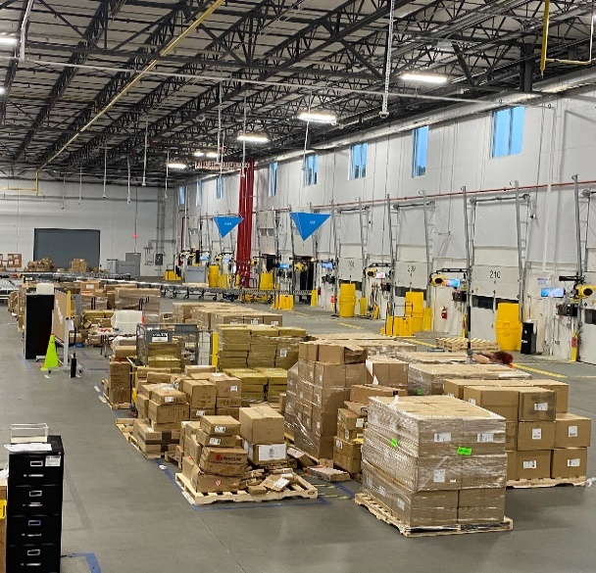KRB2 problem solve department historically staffed one to two problem solvers at a time. Armed with the traditional Zebra handheld scanners and mobile carts, associates would rarely use the four desktop computers that were provided to them in the problem solve department. Associates would remove cartons from the kick-out line and process them in the order that they were kicked out. This oftentimes led to disorganization, as the associates would have to frequently switch between multiple tabs to process each carton. The inefficiency led to massive amounts of pallet backlog.

Pallets were stored in overflow, far away from problem solve, causing them to be forgotten and not completed in order.

During periods with a high carton kick-out volume, problem solve associates would palletize the unprocessed cartons and move them to dock side of the PID, which is opposite of the problem solve department. This procedure only worsened the state of problem solve, as it required a lot of time to walk to the other side of the PID. Moreover, the overflow pallets were not processed in the order that they were received—this oftentimes caused a contribution to IOL, as some pallets would remain unprocessed for multiple days.

Figure : Old Problem Solve Overflow Layout

## DESIRED STATE

The desired outcome of this project is to improve exception handling rates, reduce labor hour spend, and decrease pallet backlog.

Moving the overflow area closer to the problem solve department will reduce backlog by consolidating the area and reducing travel distances. Moreover, removing the two desktop computers and trash bin from the left-side of the kick-out line (also referred to as the Carton PrEditor area) will allow an associate to scan and sort boxes into cages without interruption. These sorted cages will be efficiently processed by the problem solver on the right-side of the kick-out line (also referred to as the Problem Solve area), as they will be able to remain in a given function until the entire cage is processed. Finally, associates will be equipped with ProGlove scanners, which allows them to use both hands at all times and scan with ease and efficiency.

Figure : Problem Solve Overflow Route; Before and After

## PROJECT RESULTS

Figure : Amount of Pallet Backlog vs Total Carton Volume. Note: Pallet backlog data was obtained daily from the #krb2-ib-handoff Slack channel on a daily basis, between 06/12/2022 and 08/15/2022. All other data was obtained from the FCLM Database.

1. **Path of Travel Annualized Savings:**

|  |  |
| --- | --- |
| Annualized Cost Savings | **$13,801.56** |

1. **Reduced pallet backlog by 62%.**

|  |  |  |  |
| --- | --- | --- | --- |
| Avg. Pallets, Pre-Imp | 12.03 | Avg. Volume, Pre-Imp | 9036 |
| Avg. Pallets, Post-Imp | 4.55 | Avg. Volume, Post-Imp | 14542 |
| % Decrease in Pallets | **62%** | % Increase in Volume | **38%** |

1. **Increased each receive rates by 6%.**

|  |  |
| --- | --- |
| JPH, Pre-Imp | 9.35 |
| JPH, Post-Imp | 9.92 |
| % Each Receive Rate Increase | **6%** |

1. **Decreased labor hour spend by 15%.**

|  |  |
| --- | --- |
| Total Paid Hours, Pre-Imp | 131.03 |
| Total Paid Hours, Post-Imp | 111.09 |
| % Decrease in Labor Hour Spend | **15.2%** |

|  |  |
| --- | --- |
|  |  |

## FINANCIAL ANALYSIS

## After estimating the average number of cages moved to overflow during a shift, we timed the amount of time it takes to move a cage to and from overflow for both the current and desired model. The amount of time saved is 150 seconds per trip. Using an average of 15 cages per shift, the annualized savings from labor hours is $13801.56.

|  |  |
| --- | --- |
| Time saved in a single move | 150 |
| Total time saved (min) | 37.5 |
| Cost savings for each shift | $18.91 |
| **Annualized Cost savings** | **$13,801.56** |

Moreover, the labor spend reduction in problem solve that resulted from the implementation of our project resulted in a $600/week savings. Below are the weekly and annualized figures.

|  |  |
| --- | --- |
| **Avg. Weekly Cost, Pre-Imp** | $3963.66 |
| **Avg. Weekly Cost, Post-Imp** | $3360.47 |
| **Annualized Cost Savings, Labor** | **$31,365.62** |

## SAFETY

This project emphasizes the improvement of safety in the PS department by eliminating the need to stack cartons on top of the table. The new system allows only one carton on the table at a time, preventing associates from stacking them on top of each other.

Moreover, the glove scanner allows the user to scan without bending their wrist, which aids in preventing musculoskeletal disorders which result from overuse. Finally, glove scanners eliminate the need to hold a scanner while simultaneously carrying a carton, which is also a safety hazard. Associates can easily carry a box with both hands while utilizing the ProGlove scanner.

## PROJECT RISKS

Figure : Safety Hazard from Previous Layout

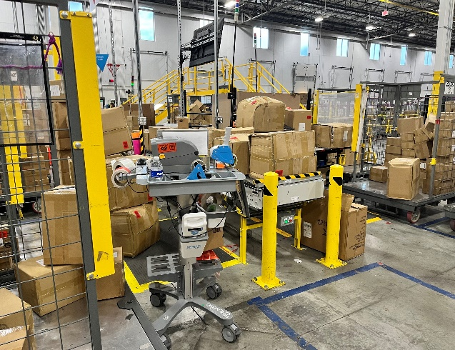Risks to this project include the loss of ProGloves due to the fact that they are small and easy to accidentally take home or leave unattended. Associates may also forget to remove the battery and place it on a charger before leaving, which could prevent the next shift from having a fully charged glove scanner.

The greatest threat that the new process poses is if the process assistant or area manager does not increase the problem solve headcount to two when cages begin to fill faster than they can be processed. This can be prevented by making sure that if a sorted cage from the Carton PrEditor side fills before the problem solver can finish processing their cage, an extra person should be moved in to help.

Figure : Risk of Staffing One Associate During High Kick-Out Volume

## APPENDIX

**Training Module**

